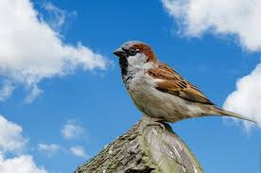
Welcome to Sparrows’ Autumn 2 Spelling Grid.
Please encourage and support your child in learning one list of spellings per week.
There will not be a weekly spelling test although please feel reassured your child’s spelling progression will continue to be monitored.
I have also included a copy of the Year 2 Common Exception Words if you would like to help your child consolidate their Year 2 spelling knowledge.
Thank you for your support, Mrs. Burgess


