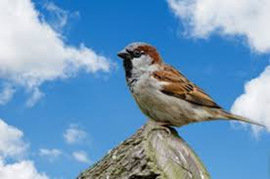
Welcome to Sparrows’ Summer 2 Spelling Grid.
Please encourage and support your child in learning one list of spellings per week.
There will not be a weekly spelling test although please feel reassured your child’s spelling progression will continue to be monitored. The following spellings are a revision of spelling rules. I have also included a copy of the Year 2 Common Exception Words if you would like to help your child consolidate their Year 2 spelling knowledge.
Thank you for your continued support, Mrs. Burgess



