Finches Haiti Explorer Challenge Thursday

Learning Objective
To learn about the country of Haiti and compare it with life in the UK.
- Find Haiti on a world map.

- Questions:
- Which continent is Haiti in?
- Is Haiti an island or part of a mainland country?
- What colour is the Haitian flag?
- Read or watch information about Haiti and find out:
- What language do people speak?
- What is the capital city?
- What foods are popular?
- What is the weather like?
- What makes Haiti special?
Record your answers in a fact file. And draw a picture of the flag.
- Choose ONE:
Option A: Travel Brochure
Create a colourful leaflet encouraging people to visit Haiti. Include:
- Pictures
- Facts
- Things to see and do
- Food to try
Option B: Postcard from Haiti
Imagine you are on holiday in Haiti. Write a postcard home describing:
- What you can see
- What you have done
- How the weather feels

- Challenge Task
Compare Haiti and the UK.
Haiti UK
Weather
Language
Food
Landscape
Write three similarities and three differences.
- Reflection
If you could visit one place in Haiti, where would you go and why?
- Further challenge:
Please design a piece of Haitian-inspired artwork using bright colours inspired by the country's famous paintings and street art. See below

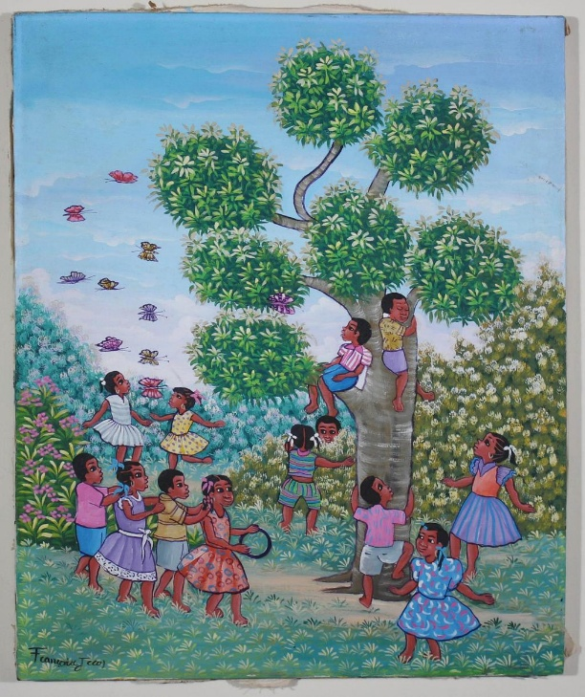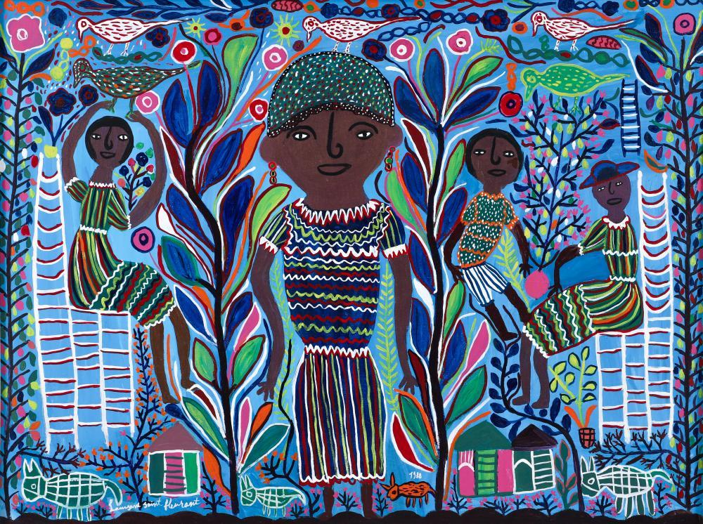
Please bring this work in as part of our geography topic this term so we can celebrate it.

