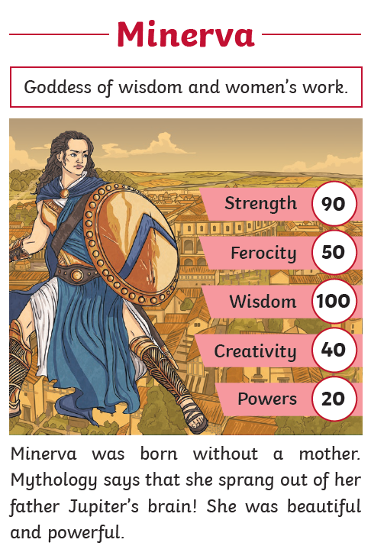
Finches Romans activities - Wednesday

Learning Objective
To learn about the different Roman Gods.

1. Create a Roman God Top Trumps Card
Choose a god and create a card including:
- Name
- Powers
- Symbol
- Animal
- Interesting fact
- Power rating out of 10
Here is an example of what your card could look like. You may choose a different design.
You might like to make a set of cards so that you can play a game of Top Trumps with someone in your family!
2. Create a comparison table between the Roman and Greek Gods:
How do the Roman Gods compare to the Greek Gods? Here is an example of a table you could create comparing the Roman and Greek Gods.
Roman God | Greek God | Role | Symbol
Jupiter | Zeus | King of the Gods | Lightning bolt

3. Create a quiz on PowerPoint about Roman Gods:
Could you create a quiz for someone in your family about Roman Gods, use animation to see if you can show the answer after each question. You could do a multiple choice quiz, so it is easier for the person doing it to choose an answer!
4. Make sure you read your school reading book and write this in your reading diary. You could also do TTRS!
Please bring into school anything you work on, or email to the office if it is electronic.

