🏠 Sparrows Home Learning Tasks for Friday 26th June 2026 🏠
French
Complete the worksheet below and match the animals with the French words.
History  This term our topic will centre around Ancient Egypt. We will learn about Pharaohs, Egyptian gods, mummification, hieroglyphics and much more.  Take a piece of A4 paper and split this up into 8 squares. In each square draw a cartoon sketch about daily life in Ancient Egypt.  https://www.bbc.co.uk/bitesize/topics/zg87xnb/articles/zqmyydm?scrlybrkr=f5615bb6 | RE  Our Big Question this term – How does His treatment of outcasts speak to Christians today?  Can you find the story of Jesus healing the lepers, in the Bible - Luke 17:11-19.  Read the story and reflect upon the your RE learning to help you complete the worksheet. | Geography  Create an information leaflet about a county in the United Kingdom. You will most probably need to complete some research to help you.  You could include:  - Where the county is located in the United Kingdom.  - Size and population of the county  - What the county is famous for.  - Are there any famous landmarks?  - Is anybody famous from this county?  - What interesting things are there to do here?  - Pictures  There is a template below if you would like to use this.
English  Choose an ancient Egyptian god or goddess.  Create a poster about them.  Make sure to remember amazing adjectives to describe them!  Fancy some fun?  Follow the link below and scroll down to the quiz. Can you get all the questions, correct?  https://www.bbc.co.uk/bitesize/topics/zg87xnb/articles/z4m8pg8 | Maths  We are learning about time and the 24-hour clock in Maths.  Complete the activity sheet below.  (Please continue to sue TTRockstars to help with rapid recall of timetables). | Science  This term we are learning about plants.  Please see the home learning activity below.

Geography - Information leaflet template
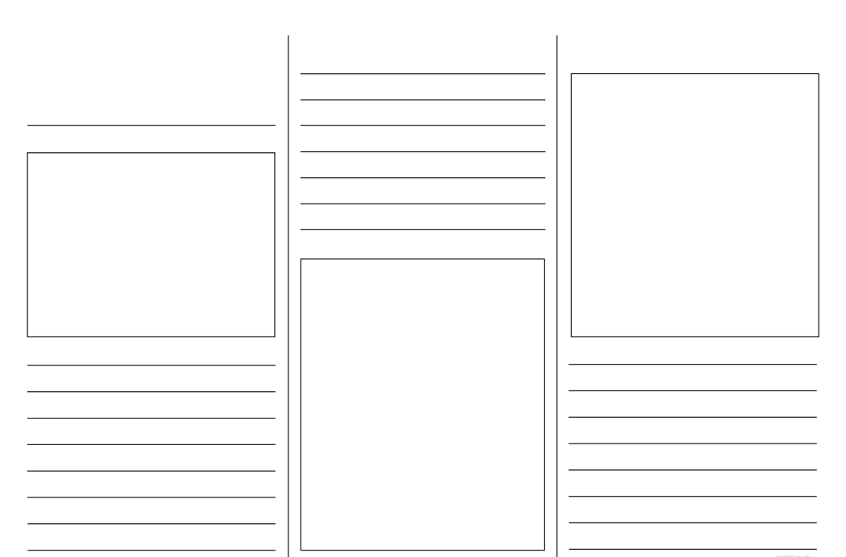

Science - Plants

Use your artistic skills to make a drawing, painting or model of a plant (with or without flowers) using any materials that you have at home. Try to use a real-life plant, may be one in your house or garden, so that you can closely observe and copy the colours and details. If you can, use colour accurately, such as paints, pastels, pencils or pens.
I look forward to seeing how creative you can be.

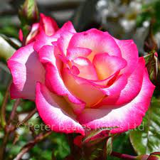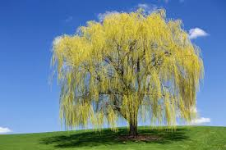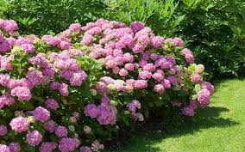

French – Matching activity - Animals
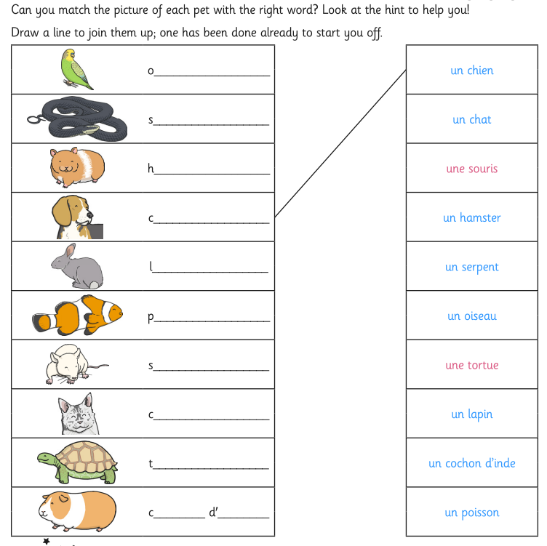
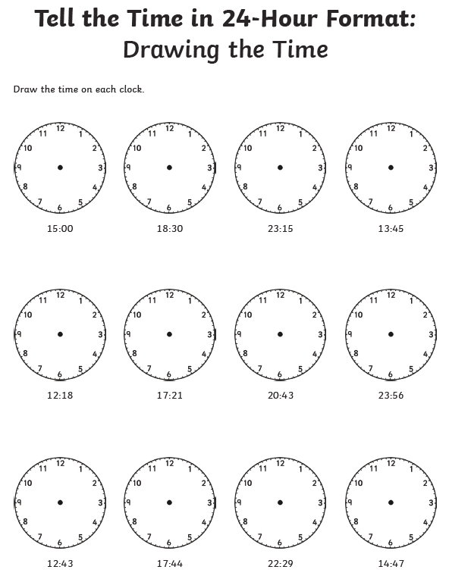
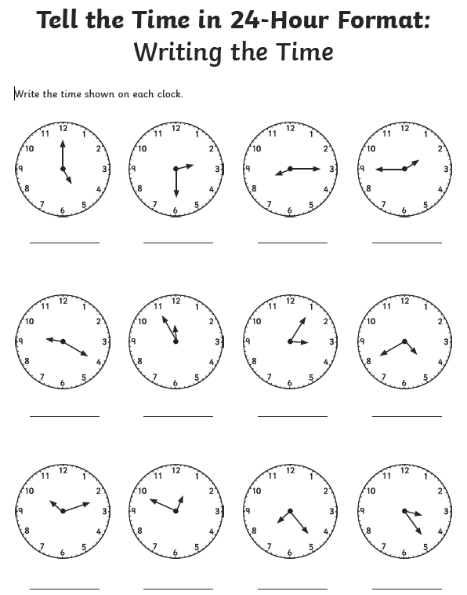
Maths – Time – 24-hour clock

