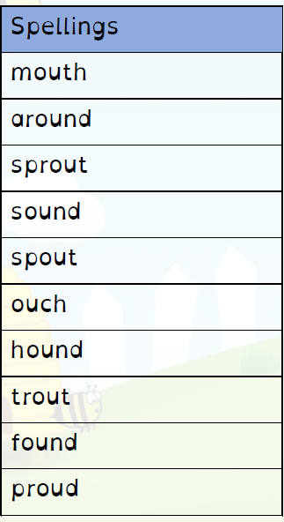
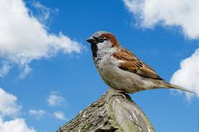

Welcome to Sparrows’ Autumn 1 Spelling Grid.
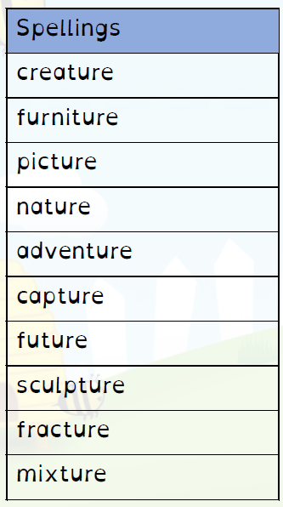
Please encourage and support your child in learning
one list of spellings per week.
There will not be a weekly spelling test although please feel reassured your child’s spelling progression will continue to be monitored.
Please find a copy of the Year 2 Common Exception
Words on the Sparrows’ class page if you would
like to help your child consolidate their Year 2 spelling knowledge.
Thank you for your support,
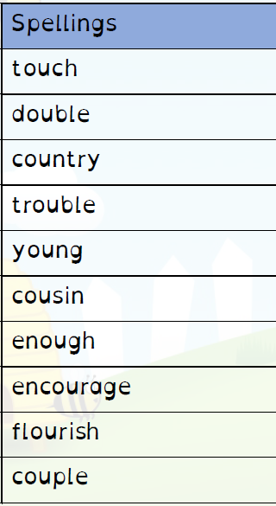
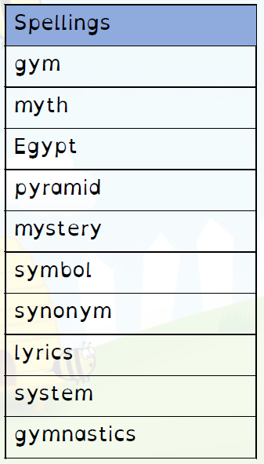
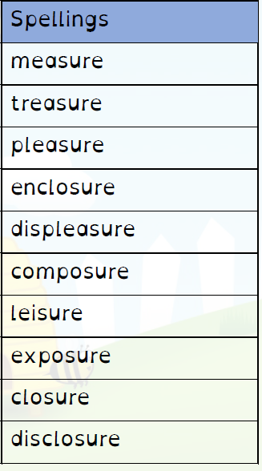
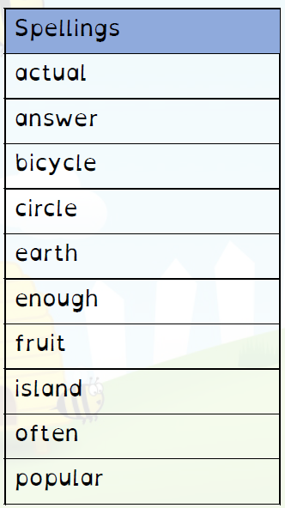
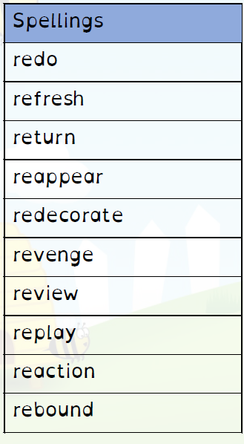
Mrs. Burgess

