St Paul’s Nursery – POSSIBLE THEMES for 2024/25
 | THEMES
 | AUTUMN 1 | AUTUMN 2 | SPRING 1 | SPRING 2 | SUMMER 1 | SUMMER 2
 | Marvellous Me!  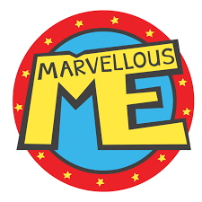 | Once Upon a Time...  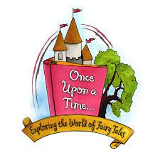 | Around the World   | Let’s celebrate   | Amazing animals  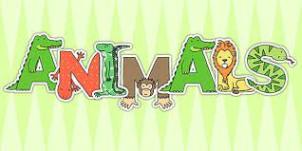 | Fun at the seaside  (And animals continued)  
 | Starting school – rules and routines.  All about me –  Physical appearance, Senses, feelings, our homes and families.  Feelings and Emotions.  Harvest and being healthy and farms.  Special Celebrations.  Harvest Festival  Roshhashanah  Sukkot  Autumn and hibernation | People who help us  Road Safety Week  Bonfire Night and fireworks  Remembrance Day  Diwali  Advent  Christmas  Traditional tales and Nursery Rhymes  Special Days  Diwali  Christmas  Autumn | Winter Wonderland.  All about me – being healthy – Exercise, diet and hygiene  Birds  Special days.  Shrove Tuesday  Valentines Days  Mental Health Week  Great Big Garden Bird Watch.  Winter | Holi Festival  Easter  Chinese New Year.  Special Days  Lent  Mother’s Day  Great British Science Week.  Easter  Holi  Chinese New Year  Winter leading to spring | Life Cycles (Ducklings, plant, frog)  Ducklings hatching.  Sunflowers  Dinosaurs  +  Special Days and celebrations.  Father’s Day  Eid  Spring | - Holidays, Seaside and other countries  - Minibeasts (Butterfly life cycle)  - Recycling and looking after the world.  Summer,
 | Seasonal changes = Autumn to Winter |  | Seasonal changes Winter – Spring |  | Seasonal changes – Spring to Summer
 | Stories in the book corner and environment. Books highlighted in green are used more in the teaching to promote activities in the curriculum.
 | - A handful of buttons  - Colour Monster  - Elmer.  - Be You!  - Rainbow fish  - The Perfect Fit  - Three Little Pigs  - We’re going on a leaf hunt.  - Ouch!  - Leaf man  - Cave Baby.  - Goldilocks and the 3 bears.  - Little Red Hen.  - Our House  - Supertato  - What the ladybird heard.  - Handa’s Surprise.  - Supertato  - The Three Little Pigs  - Kitchen Disco  - The Sneds and the Snoos.  - The Healthy Wolf.  - Oliver’s Vegetables  - Oliver’s fruit salad.  - Handa’s Surprise.  - Bear snores on.  - Owl Babies  - Brave as can be.  - It’s Okay to be Different  - The Paper Dolls  - No Matter What  - In my heart.  - Feelings  - All kinds of feelings.  - All kinds of people  - All kinds of families.  - My many coloured days | - Rama and Sita  - Topsy and Tim safety first.  - Zog and the flying doctors.  - Three Billy Goats Gruff  - Teddy takes a tumble.  - The Owl and the Star.  - The Jolly Christmas Postman.  - Lighting a lamp  - Peppa’s Diwali.  - Dipal’s Diwali  - All About Rangoli  - CBeebies – Diwali festival.  - Child’s Eye View – Festivals - Diwali  - A Festive feast  - It’s nearly Christmas – Advent around the world.  - Toad on the road.  - One Bright Star  - Jesus Christmas Party.  - Maisie’s Christmas Eve.  - The Gift of Christmas.  - Santa’s Suit.  - The Nativity Story. | - Bear learns to swim.  - Lost and found.  - Snow bears surprise.  - Mr wolfs pancakes  - The runaway pancake  - Pip and Egg  - The Go away bird  - For the birds  - Mama Panyas pancake.  - Love monster  - Guess how much I love you.  - Snowball  - Leaf | Holika and Prince Prahlad  The magic paintbrush  Marmalade  The great race  The golden egg  The great Easter Egg Hunt.  The great egg scape. | Tadpoles promise.  Oi frog  Grumpy Frog  The Frog Prince  Ugly Duckling  Chicken Licken  The enormous turnip  Ten seeds  Jack and the Beanstalk  Jaspers beanstalk  A seed in need  The tiny Seed  A fruit is a suitcase for a seed. | - Sharing a Shell  - Billy’s Bucket  Superworm  - The Very Hungry Caterpillar.  - The snail and the whale.  - George saves the world by lunchtime.  - It’s only one]  - Somebody crunched colin  - Somebody swallowed Stanley.  - Dear Greenpeace.  - Matisse’s magical trail  - Ones a snail tens a crab  - Snail trail  Mr snails counting trails.
School value focus and stories linking with them and C of EL focus. | Courage.  C of E L – Active learning – Motivation  Tryatops  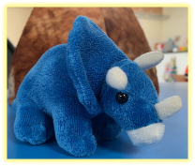 | - Respect  - C of E L – Active learning – Motivation Thinkodocus  - 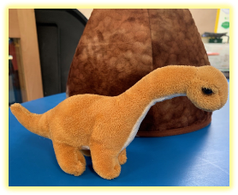 | Enjoyment  C of EL - Engagement – Active Learning-  Pretendasaurusexplorosaur.  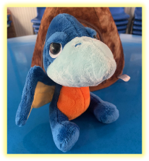 | - Hope  - C of EL –Engagement – Active Learning.  Stickosaurus  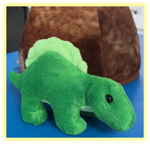 | - Community  - Cof EL – Creating and Thinking critically  - Thinking  - Solveosaurus rex and Pretendasaur.  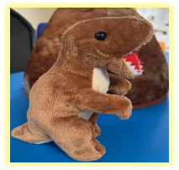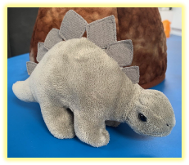
Growth mindset and value stories | - Giraffes can’t Dance  - Ish  - The Gruffalo  - The lion inside.  - Be brave  - A little bit brave.  - Courage  - Be brave little penguin  - Tilda Tries Again.  - Billy’s Bravery  - Brave – Sarah Ward.  - Jabari Jumps  - Julian is a Mermaid | - The Koala who could.  - The Squirrels who Squabbled.  - Marvin gets mad  - Have you filled a bucket today.  - The smartest Giant in town.  - Delightfully different Dilly  - The Proudest Blue  - Once upon a world collection – snow white, Rapunzel, Cinderella, snow white, Little Mermaid. | - Polar bear learns to swim.  - Geronimo  - This is me  - Pink is for boys  - The snail and the Whale  - Find your happy | - After the Fall.  - Little Mole finds hope.  - Rain before rainbows.  - A spark in the dark.  - The princess and the Wizard  - The Singing Mermaid.  - How the Crayons saved the rainbow.  - The Whale who wanted more.  - Ice cream had a meltdown.  - The Hole Story  - Wisp – A story of hope.  - A bit lost. | - Stuck  - How to Catch a Star.  - My Truck is stuck.  - Almost  - I can’t reach it  - The enormous Turnip.  - Giraffe and a half  - The Smeds and the Smoos  - An English year  - The Panda’s who promised.  - What happened to you?  - Four bad unicorns.  - Gender swapped faiytales.
Stories and songs. linked to Christian values. | - The lost Sheep  - Our god is a great big god. | - Nativity  - Away in a Manger. | - The Good Samaritan. | - Noah’s Ark  - The Easter Story.  - The Animals went in 2 by 2.  - Jesus is alive - https://www.mindyjonesblog.com/christian-easter-songs-for-kids-sing-along/  - Who built the ark. | - The Creation Story  - What a wonderful world. Calming song. | - Jonah and the whale
Songs and  Traditional Nursery rhymes. | .  - I have a body.  - If your happy and you know it.  - Touch your head.  - Head shoulders knees and toes.  - Finger rhymes – tommy thumb, one little finger, 2 little dickie birds.  - Twinkle Twinkle Little star.  - Dingle Dangle Scarecrow  - Old MacDonald had a farm.  - The farmers in his Den.  - 5 crows all shining black  - Let’s go fly a kite  - Rain Rain go away.  - It’s raining it’s pouring.  - I hear Thunder  - Oats and beans and barley grow. | - Miss Polly had a Dolly.  - Wheels on the Bus.  - 5 little monkeys.  - I’m a firefighter  - Humpty Dumpty  - Baa Baa Black Sheep  - Hickory Dockory Dock  - One, Two, Three, Four  - Five  - 10 in the bed.  - Wind the bobbin up.  - Pat-a-cake  - Stop look listen  - Twinkle twinkle traffic light.  - Ten in the bed.  - Christmas songs –  - Away in a Manger  - We wish you a Merry Christmas  - Feliz Navidad.  - Jingle Bells.  - Christmas Pudding.  - Father Christmas | - Mary had a Little Lamb  - Ring -a Ring - a Roses  - Little Bow Peep  - Row Row Row your boat.  - Jack and Jill.  - Incy Wincy Spider was climbing up a Tree.  - Oranges and lemons.  - Her we go round the Mulberry Bush. | - I can sing a Rainbow  - Doctor Foster  - The Queen of Hearts  - Ring o roses.  - Sleeping Bunnies  - Little Peter rabbit  - Hot cross buns  - 5 currant buns. | - 5 little speckled Frogs  - 5 little ducks  - I’m a little tadpole  - I’m a little seed.  - Goosey Goosey gander. | - Down in the jungle  - There’s a worm at the bottom of my garden.  - There’s a tiny Caterpillar on a leaf.  - Incy Wincy Spider  - 5 little monkeys swinging in a tree.  - Like the animals do.
 | Magical Moments | Magical Moments | Magical Moments | Magical Moments | Magical Moments | Magical Moments
 | - MacMillan Coffee Morning (chance to meet new parents and first stay and play.)  - Signs of Autumn seasonal walk.  - Harvest and farmer Day.  - Hibernation Day. (come in pyjamas)  - One Can Trust shop and donations.  - Mystery readers and Super story sessions. | - Christmas Grotto.  - Special visit from Father Christmas  - Nativity performance  - Fire brigade visits nursery  - Dental Nurse visit.  - Police Visit. (Road Safety Visit)  - Magical Christmas Elf.  - Decorating the Nursery.  - Advent mornings.  - Cooking and food tasting for Diwali.  - Mystery readers and Super story sessions. | - Making and tasting pancakes.  - Signs of winter walk.  - Delivery of the penguin egg!  - Valentines day stay and play.  - Mystery readers and Super story sessions. | - Signs of Spring seasonal walk  - Science week  - Holi/ Chinese new year celebration day.  - Mystery readers and Super story sessions.  - Story stay and play. | - Mystery readers and Super story sessions.  - Duckling life cycle – Hatching eggs  - Butterfly life cycle. | - Teddy Bears Picnic in Nursery children to bring their own Teddy Bears to join them.  - We’re going on a BEAR Hunt!  - Signs of Summer seasonal walk  - Nursery rhyme sports day.  - Fit for life week.  - Mystery readers and Super story sessions.
SMSC | Mutual Respect  - Being polite and respectful towards others.  - Using our manners with everyone.  - Recognising similarities and differences between yourself and others. | Tolerance  - Being able to be you, developing confidence in what you can do!  - Trying a range of different activities and opportunities to discuss and select what you like/ dislike.  - Opportunities to take risks, challenges and responsibilities.  - Asking questions and knowing your opinions is valued and respected.  - Opportunities to develop your own ideas.  - Joining in and challenge activities that are seen as “just for boys” or “just for girls”.  Being positive about yourself! | - Rule of Law  Working together to create rules.  Talking about why we need rules and how they need to be fair so everyone is safe and happy.  Understanding your own and others’ behaviour feelings, and the consequences.  Working together to have a happy and safe environment e.g. following class and school rules, follow ups on discussions and other choices explored after taking a vote.  Learning the difference between right and wrong.  Taking turns, sharing and compromising on ideas. | - Individual Liberty  - Being able to be you, developing confidence in what you can do!  - Trying a range of different activities and opportunities to discuss and select what you like/ dislike.  - Opportunities to take risks, challenges and responsibilities.  - Asking questions and knowing your opinions is valued and respected.  - Opportunities to develop your own ideas.  - Joining in and challenge activities that are seen as “just for boys” or “just for girls”.  - Being positive about yourself!  P4C sessions | - Democracy  Waiting for our friends to finish speaking before we speak.  Sharing your opinion.  Taking turns and sharing.  Having your voice heard.  Listening to others.  Making decisions together.  Caring for each other.  Being able to talk about our feelings.  Seeing your role in the ‘bigger picture’, e.g. linking to part of a family, class, group, school, community etc.  Having a choice and a chance to vote.  Book vote.  Votes on activities that we want to do. | - Ways we promote the British values.  Book vote  Activity vote  Feedback Friday  P4C Sessions  Cultural celebrations  Being me in my world book  PSHE sessions  RE sessions  Class rules and Wonder Woodland rules.  Safe spaces to speak  Five hands – trusted adults.
St Paul’s Enrichments | Mindfulness and self-regulation  Weekly yoga sessions  Calm me time in PSHE  Colour monster activities and painting to music. Identifying the different emotions and moving in those ways.  Calm area in Nursery  Planning for activities that bring more mindfulness. |  | Culture and religion  Celebrations for Chinese New Year.  Holi celebration.  Stories and activities linked to celebrations.  Enrichment plan linking with KS1. | Storytelling and language enrichment.  Helicopter stories regularly.  Magic story box  Story telling using pictures with no words.  Story telling using small world.  Story telling sessions.  Culture and religion  Easter celebration  Easter tree. | Natural world enrichment  Wonder Woodlands  Natural materials in the setting to use.  Exploring seasonal natural objects.  Sorting sets of natural objects by exploring the properties.  Learning about recycling, pollution and littering through stories, songs and experiences within the community. | Healthy lifestyle enrichment.  Fit for life week  Healthy eating promotion through conversations at snack time  Cooking opportunities,  Opportunities to be active every day and speaking about the importance of this.
Makaton focuses | Signs in the routine and greetings.  Signs for emotions  Signs for family members and rooms in the home.  Baa baa black sheep in makaton.  Farm animals – Old MacDonald had a farm | Makaton story – goldilocks and the three bears.  Christmas signs – advent calendar.  Humpty dumpty | Animals that live in cold lands. | Makaton story – Dear Zoo  Makaton book – going to the park. | Animals from the life cycles.  Going to the zoo. | Signs linked to the beach.

The 3 Prime areas and 4 Specific areas are continually re-visited to support and challenge children throughout the year.
See other planning which runs alongside this thematic approach.

Please note that our planning is fluid and is determined following careful observation and assessment regarding children’s interests and needs.

